**SMART HELMET**:

SAFETY HELMET BASED ON THE SPEED

AND ALCOHOL CONTENT OF THE DRIVER

GROUP 3

**CONTENTS**:

1. BRIEF IDEA ABOUT THE PROJECT

2. MOTIVATION BEHIND THE PROJECT

3. PATENTS RELATED TO SMART HELMET

4. LITERATURE AND RESEARCH RELATED TO THE PROJECT

4. PROPOSED DESIGN

5. INNOVATIVENESS OF THE PROJECT

6. FUTURE WORK AND BUSINESS DETAILS

7. REFERENCES

PROJECT BRIEF

Nowadays the numbers of road accidents are increasing at a fast rate. In every minute, 17 persons are killed due to road accidents. And a major part of these road accidents occur due to over speeding and drunk driving. The major victims to the road accidents are the two wheeler drivers because since they are driving an open vehicle there is no protection of any kind for them. Hence we have decided to build a SMART HELMET for the safety of the bikers. This helmet warns the driver if he is drunk and over speeding. And still the biker does not agree to its warnings then it automatically switches off the ignition tank.

**MOTIVATION BEHIND THE PROJECT**

The report suggests that about **1.5 percent of all the total 4.64 lakh road accidents were caused by drunken driving or driving under the influence of drugs or alcohol, resulting in injuries to 6,295 people.**

The offense, however, according to the report, resulted in 2,988 deaths — more than 8 deaths every day — accounting for just over 2 percent of all fatalities in road accidents.  
  
**The report Road Accidents in India 2015 puts the number of accidents caused by drivers under the influence of alcohol as well as the fatalities much higher — 3.3 percent of all road accidents and 4.6 percent of all fatalities from road accidents.**  
That translates to 6,755 deaths annually or more than 18 deaths every day across the country.  
  
This further pushes up the numbers — 4.2 of all accidents caused due to the driver’s fault and 6.4 percent of all such deaths was due to the consumption of alcohol by the driver.

In 2011, the Ministry had admitted that drunken driving was one of the leading causes of road accidents and attributed as many as 27,152 accidents to it.

**STATS RELATED TO DRUNK DRIVING**

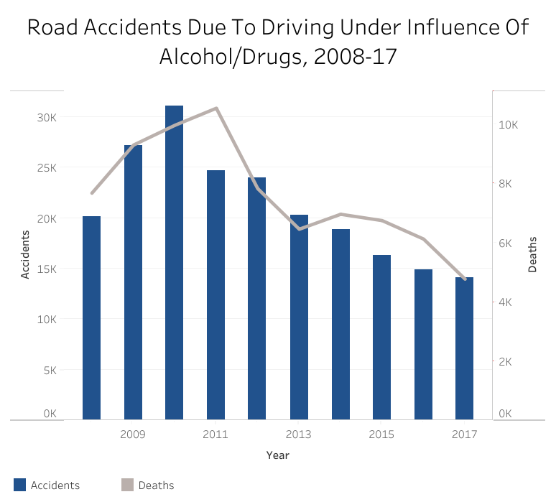

We also found that a major number of accidents occur due to over speeding.

Over-speeding is a major killer, accounting for 64.4% of the persons killed. This category was followed by driving on the wrong side of the road, which accounted for 5.8% of the accident related deaths. Use of mobile phones accounted for 2.4% of the deaths and drunken driving accounted for 2.8% of the persons killed.  
  
Not wearing helmets and seat belts are not causes of crashes, but are critical for avoiding grievous injuries and fatalities. As many as 43,614 deaths or 28.8% of total road accident deaths in the country last year were caused due to “non-wearing of helmets”. “Non-wearing of seat belts” was linked to 24,435 deaths or 16.1% of total road accident deaths in the country. Among the States, Tamil Nadu (13.7%) topped the country in terms of the total number of road crashes.

SOME STATS RELATED TO OVERSPEEDING:

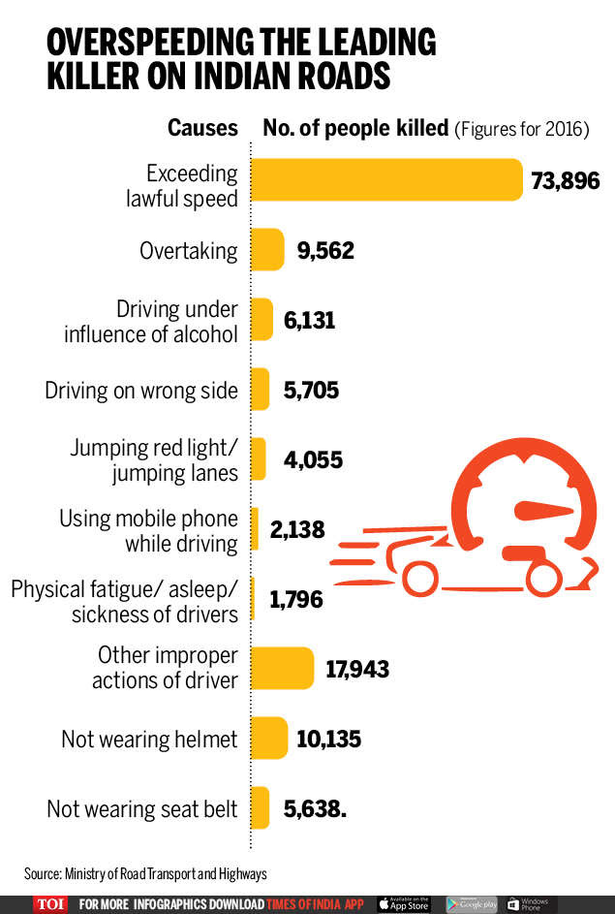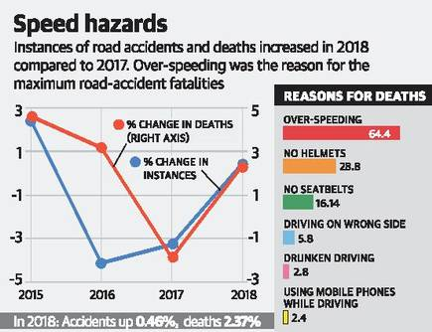

PATENTS RELATED TO SMART HELMET

Before starting the project we decided to search about some patents related to smart helmet so that we can have a background about how to proceed or whether we can use their design and make it more efficient so that it becomes viable, reliable, easy and cost effective to use for the common public.

Here are some of the abstracts of the patented smart helmet projects

PATENT 1:

A smart helmet wirelessly connected to a server includes a main body, a central processing device, a sensing device, a communication transmitting/receiving device, an image projecting device, and a power supply. With these arrangements, the smart helmet can transmit different signals sensed by the sensing device to the central processing device. After being processed, the processed signals are uploaded to a cloud server via the communication transmitting/receiving device, and the cloud server sends data processed from the signals back to the central processing device via the communication transmitting/receiving device, then the data is turned to an image data to project. Or the smart helmet is capable of remotely monitoring a user's driving information and safety.

PATENT 2:

A smart helmet included integrated electronics providing safety and convenience features. Helmet features includes a global locating system, an environmental interaction sensor, a mobile communications network device, a small display panel, a microphone and at least one speaker. The helmet is aware of the user's location and interactions with the environment. The helmet can provide data to a user, monitor the user's actions and condition, and send information to others about user's location and condition.

Here are the links related to the patented smart helmet projects:

1. <https://patents.google.com/patent/US20160210933A1/en>
2. <https://patents.google.com/patent/US6798392B2/en>

On reading the patents we realized that these helmets are only smart and have no provisions for the safety of the driver. Therefore we realized that it is necessary to make a safety smart helmet. And thus we got the motivation for making the project.

LITERATURE AND RESEARCH RELATED TO THE PROJECT

We researched a lot about the speed at which most accidents occur and we found that:

**Approximately 70 percent of all fatal crashes on roadways with speed limits of 40 mph or less are in** **urban areas. Slightly less than half (47%) of all fatal crashes occurring on roadways with speed limit between 45 and 50 mph are in rural areas. Over 70 percent of the fatal crashes on roadways with speed limit of 55 mph or higher occur in rural areas.**

Therefore we decided to keep an appropriate speed limit of 60 Km/hr for people who are non drunk.

We also found that:

**Approximately 24 percent of rural and urban drivers involved in fatal crashes had a positive blood alcohol concen­tration (BAC). How­ever, the per­centage of rural drivers with more severe BAC levels was generally higher than the corresponding percentage of urban drivers with similar BAC levels.**

**For 70 percent of alcohol-impaired-driving fatalities, at least one driver in the crash had a BAC of .15 grams per deciliter or higher.**

**The age group with the highest percentage of drivers with BACs of .08 or higher was 21 to 24 years old.**

Therefore we decided to set the BAC level to 0.08. Above which the person is considered to be drunk according to our sensors.

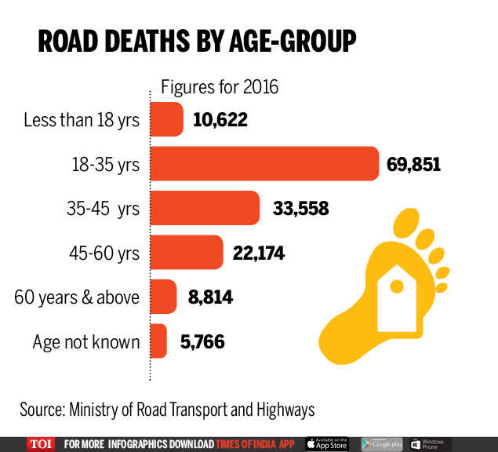PROPOSED DESIGN:

Components of the project:

1. Speed sensor
2. Gas Sensor
3. Arduino
4. Motors
5. Wireless Transceivers
6. Battery

Procedure:

There would be a total of four circuits:

MAIN CIRCUIT:

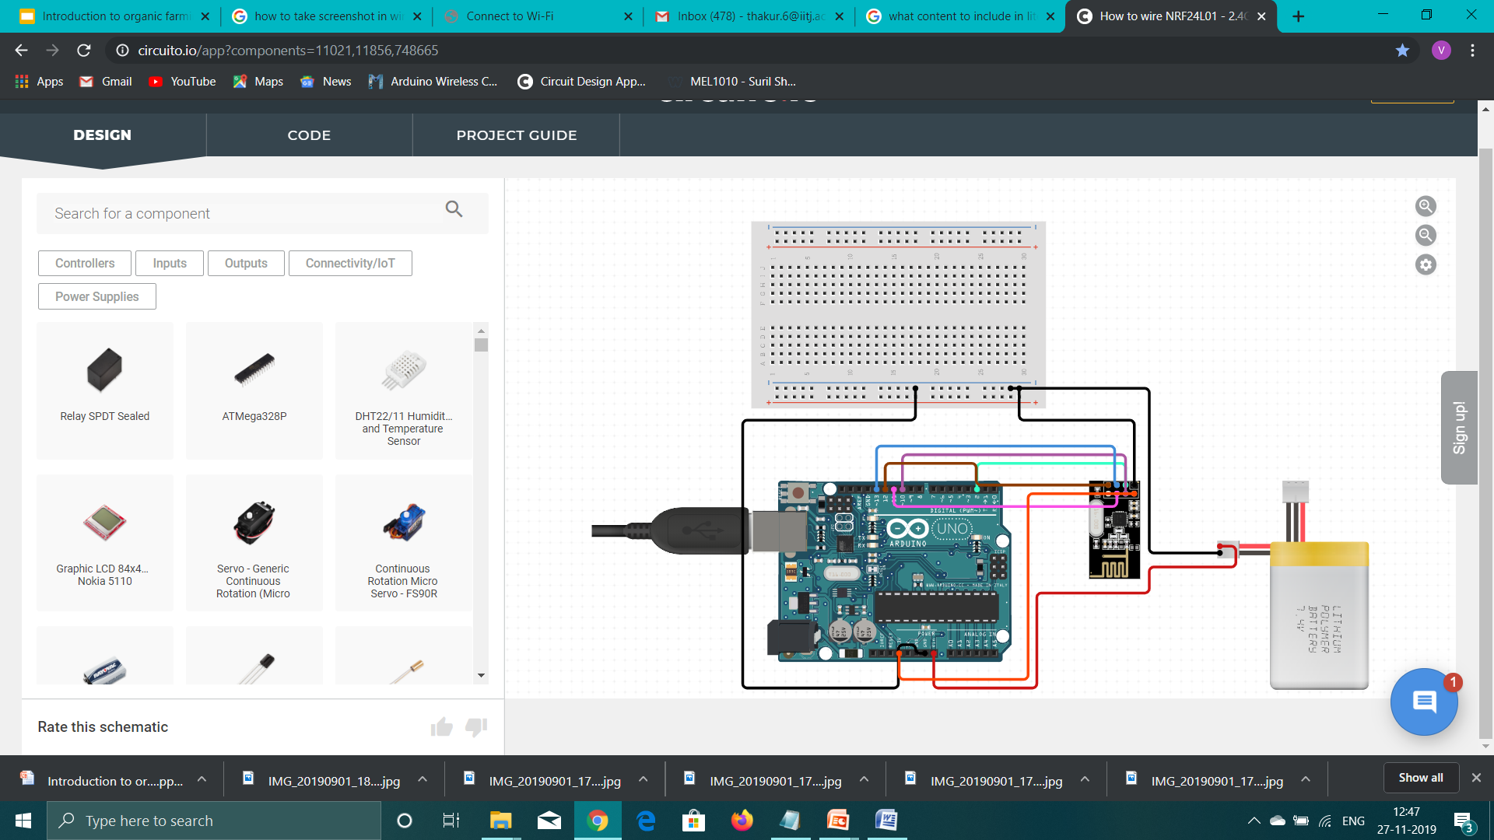This is the main circuit which contains Arduino, a wireless transceiver, a battery which controls the other two circuits wirelessly. This circuit is attached to the bike at the back part.

ALCOHOL DETECTION CIRCUIT:

This is the alcohol detection sensor circuit. This circuit contains an Arduino, gas sensor, battery, wireless transceiver, buzzer and a Led. This circuit will detect if there is any alcohol content in the driver’s breath and accordingly will send signal to the Main Circuit and lit the Led and the buzzer will sound.

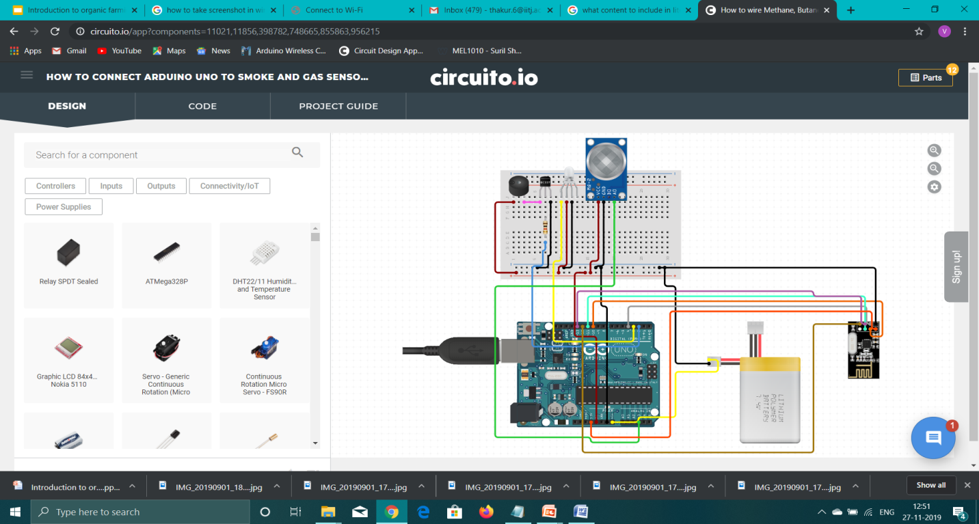

SPEED DETECTION CIRCUIT:

This circuit is present at the axle of the wheel. We have used hall sensor for detection of speed. The other components are Arduino, wireless transceivers, battery.

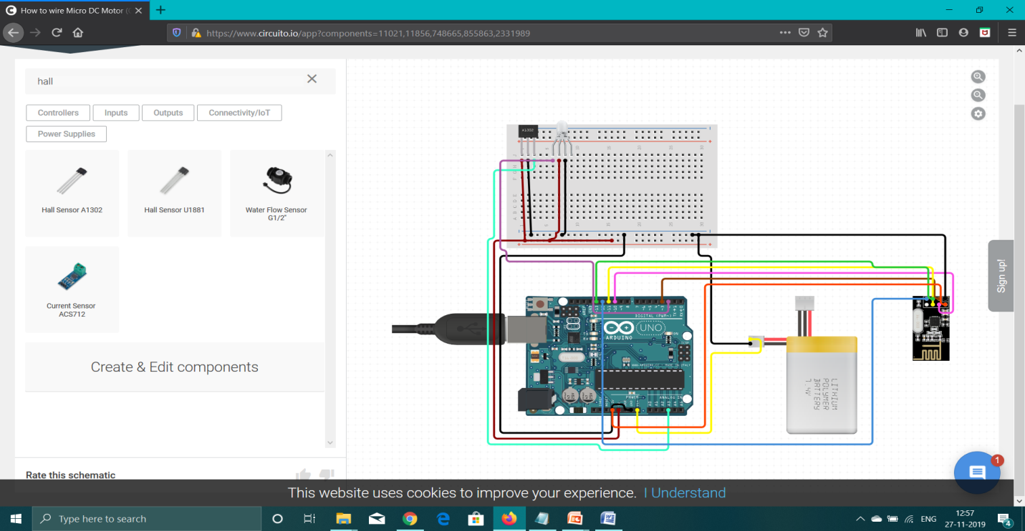

IGNITION TANK CONTROLLER CIRCUIT: This circuit is present near the knob of the ignition tank of the circuit and the parts in it are motors for turning off the knob, Arduino, wireless transceivers and a battery.

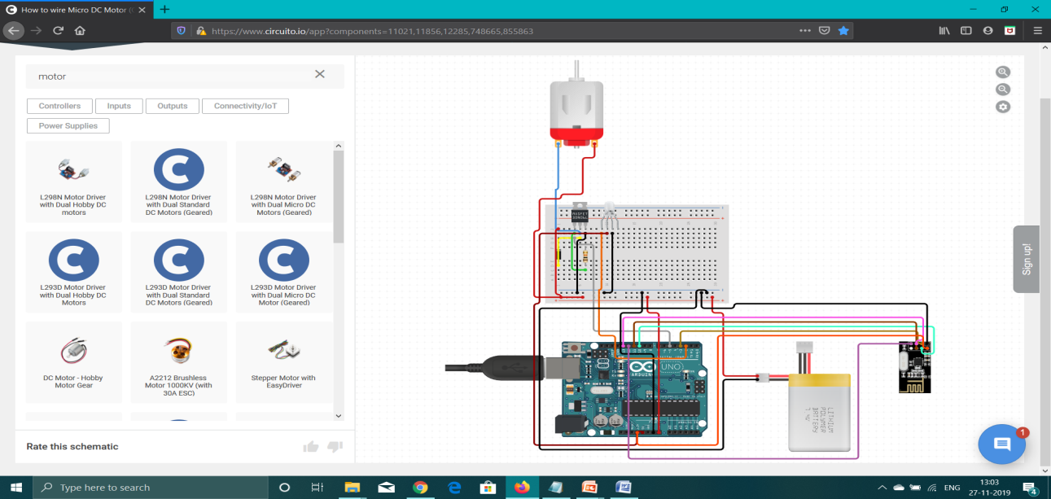

PARTS USED IN THE CIRCUIT:

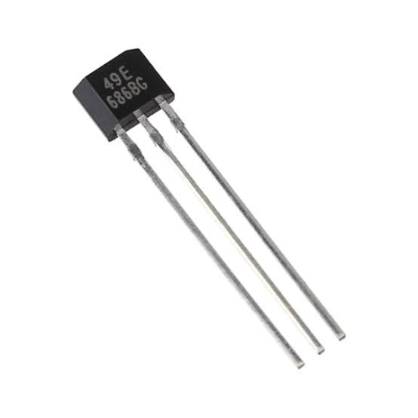HALL EFFECT SENSOR:

It is a device that is used to measure the magnitude of a magnetic field. Its output voltage is directly proportional to the magnetic field strength through it Hall Effect sensors are used for proximity sensing, positioning, speed detection, and current sensing applications. Hall sensors are commonly used to time the speed of wheels and shafts, such as for internal combustion engine ignition timing, tachometers and anti-lock braking systems.

WIRELESS TRANSCIEVER-

It consists of a transmitter and a receiver. In the transmitter, a process known as modulation converts electrical digital signals inside a computer into either RF or light, which are analog signals. Amplifiers then increase the magnitude of the signals prior to departing an antenna.

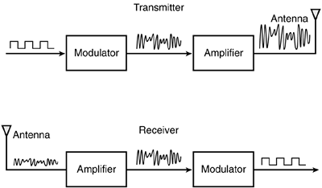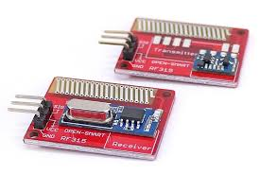

ARDUINO-

It is an open-source hardware and software company, project and user community that designs and manufactures single-board microcontrollers and microcontroller kits for building digital devices. Arduino board designs use a variety of microprocessors and controllers. The boards are equipped with sets of digital and analog input/output (I/O) pins that may be interfaced to various expansion boards ('shields') or breadboards (For prototyping) and other circuits. The boards feature serial communications interfaces, including Universal Serial Bus (USB) on some models, which are also used for loading programs from personal computers. The microcontrollers can be programmed using C and C++ programming languages.

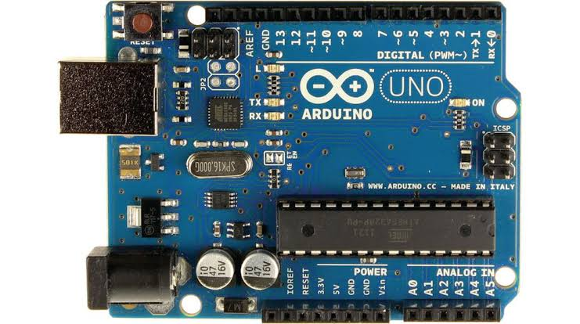

GAS SENSOR:

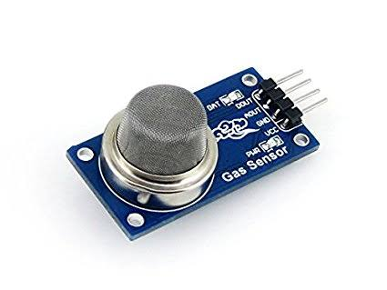It is a device which detects the presence or concentration of gase**s** in the atmosphere. Based on the concentration of the gas the sensor produces a corresponding potential difference by changing the resistance of the material inside the sensor, which can be measured as output voltage.

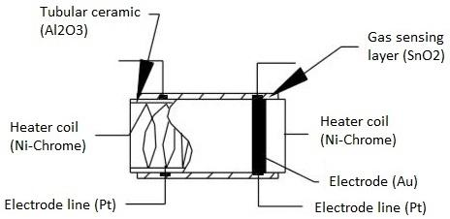

OVERALL WORKING OF THE CIRCUIT:

The Speed sensor detects the speed of the vehicle and the gas sensor detects whether the person is drunk or not. If the person is drunk (>=0.8BAC) and is exceeding the speed of 30km/hr then the buzzer would start ringing indicating the driver to stop the vehicle but still if the driver does not do so then the Main Circuit would give directions to the Ignition Control Circuit to turn off the fuel supply. Similarly if a non drunk person is exceeding the speed of 60 km/hr then the same process would repeat again.

LITERATURE AND RESEARCH RELATED TO THE PROJECT

We researched a lot about the speed at which most accidents occur and we found that:

**Approximately 70 percent of all fatal crashes on roadways with speed limits of 40 mph or less are in** **urban areas. Slightly less than half (47%) of all fatal crashes occurring on roadways with speed limit between 45 and 50 mph are in rural areas. Over 70 percent of the fatal crashes on roadways with speed limit of 55 mph or higher occur in rural areas.**

Therefore we decided to keep an appropriate speed limit of 60 Km/hr for people who are non drunk.

We also found that:

**Approximately 24 percent of rural and urban drivers involved in fatal crashes had a positive blood alcohol concen­tration (BAC). How­ever, the per­centage of rural drivers with more severe BAC levels was generally higher than the corresponding percentage of urban drivers with similar BAC levels.**

**For 70 percent of alcohol-impaired-driving fatalities, at least one driver in the crash had a BAC of .15 grams per deciliter or higher.**

**The age group with the highest percentage of drivers with BACs of .08 or higher was 21 to 24 years old.**

Therefore we decided to set the BAC level to 0.08. Above which the person is considered to be drunk according to our sensors.

INNOVATIVENESS OF THE PROPOSED SOLUTION

The SMART HELMET project is innovative in its own way. First of all it would reduce the number of road accidents in a great number. Several elements have been added which give it a plus point over other SMART HELMET projects:

1. SAFETY FACTOR-

So far the project and patents that we have seen on the internet aim to give the driver all kinds of recreation. For example there are provisions for the driver to pick and drop calls. You can also play music in your helmet. It gives the location of driver but there are no provisions for the safety of the driver. We have focused on the safety of the driver. Using our helmet the driver would safely drive. There are speed sensors which take a note of the driver’s speed and prevent him from over speeding.

1. BASIC DESIGN-

The design has been made using some basic sensors which we all know and have a general idea to operate. Also all the connections have been done wirelessly without any actual wire which makes the circuit design simple and avoids complications.

1. OPEN CODE-

We have kept the code open. But the permissions to change the code only lies with the hands of a Registered RTO officer. This is due to the fact that the over speeding limit changes with different terrains. We cannot have the same limit in a hilly region and on plains. So the circuit and our helmet are not rigid to any perfect situation.

1. COST EFFECTIVE-

The cost of our project is not exceeding 3000 rupees. So it is relatively cheap and could be used by any middle class men and women. Also it is subject to change once there is mass production.

1. FLEXIBLE WOKFLOW-

Since there is an alarm signal and not a direct switching off of the vehicle the device is easy and flexible to use. We are switching off the fuel tank only for the reason that the vehicle does not skid and the driver gets hurt.

**FUTURE WORK-**

We have divided ourselves in groups:

The mechanical and bio engineering students are going to work with the mechanical part of the project like attaching hall sensor to the axle and attaching motors to ignition tank.

The CS students would work with the coding part of ADUINO

The Electrical students would work with the connection of parts with the circuit and also with the connection of one circuit to other.

**BUSINESS DETAILS-**

Our main target customers would be all the two wheeler drivers and also for drunk drivers. Since our HELMET gives a warning before actually coming into action, it would be in great demand as there is no strict stopping of the vehicle.

Traffic Police would also encourage drivers to use this since it would be easy for them as they would not require to check any driver.

Also government would promote such a HELMET and since it is cost effective everyone would be ready to buy and due to the points included in innovativeness of the proposed solution the product would be in high demand in the market.

CONTRIBUTION OF EACH GROUP MEMBER:

1. Ved Thakur- Group leader, did all the designing of circuits and coding them
2. Vamshi Krishna- Searched about sensors and their applications
3. Vikas Shekhawat- Searched about Gas sensor and its range of detection
4. Venkatesh Patnala- Idea provider
5. Vedanshu Goyal-making of presentation
6. Kanishka- Searched about Hall Sensor and its application in the project
7. Sai Krishna- Helped in designing the project report
8. Vikas Meena- Searched about the literature related to the project
9. Vamshi Vardhan- Searched for the Motivation related to the project
10. Yash Kumawat- Designed the SMART HELMET using solidworks

THANK YOU